South Carolina Good Sam
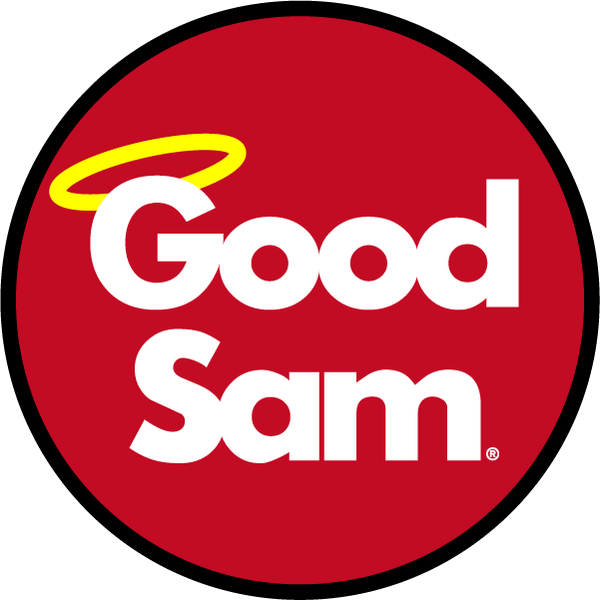
2022 Spring RV Rally
State Directors, Tim and Debbie Carroll
& the SC Good Sam Staff
Welcome you to our Spring Rally
Theme – CARNIVAL
May 12th-15th, 2022

LOCATION: | Palmetto Cove Inc RV Park 521 Table Rock Rd, Cleveland, SC 29635
DATES: | Rally – May 12th through 15th - Early Bird starts May 8th, 2022
ACTIVITIES: | Entertainment (2 Nights), Continental Breakfasts (Fri/Sat), Catered Meal Friday night, Games, Samgo, Door Prizes, Hospitality, Chinese Auction, 50/50, puzzles
CATERED MEAL: | Chopped Pork, Baked Beans, Cole Slaw, Potato Salad and Banana Pudding.  Friday Night - $15.00 per person.
THEME: | “CARNIVAL”
REGISTRATION:
- Must be received by April 21st to be parked in preassigned area with your Chapter.
- Registrations are for a single family—Single Family is defined as “Parent(s)/guardian & children under 18 years old.” All others are considered guests.
- Fellowship Package are for those that want to come and enjoy the sights and sounds but not camp
CANCELLATIONS:
- If received By Apr 21st – Honored/refunded, LESS a $10.00 cancellation fee.
- If received after Apr 21st - NO REFUNDS
- NO REFUND FOR NO SHOWS!!
You MUST supply your tow/towed vehicle information on the registration form

2022 SOUTH CAROLINA FALL RALLY
May 12-15th
Palmetto Cove Inc RV Park
521 Table Rock Rd, Cleveland, SC 29635
Theme - CARNIVAL
SC State Directors: Tim & Debbie Carroll State Website: www.SCGoodSam.com
Name: Click or tap here to enter text. |  |  | EMAIL: Click or tap here to enter text.
Address: Click or tap here to enter text. |  |  |  |  | Phone: Click or tap here to enter text.
Good Sam #: Click or tap here to enter text. |  | Chapter Name: Click or tap here to enter text.
RV Type: ☐TT ☐MH ☐5th Wheel ☐Other |  |  | #Slides: |  |  | RV Length:
Camper Make: Click or tap here to enter text. |  |  |  | Tag# & St: Click or tap here to enter text.
Tow(ed) Vehicle Make: Click or tap here to enter text. |  |  |  | Tag# & St: Click or tap here to enter text.
# Adults: | # Children (<18): |  | Your first SC Rally? YES ☐ NO ☐
REGISTRATION FEE
Arrival Date: Click or tap to enter a date. Departure Date: Click or tap to enter a date.
3 Nights camping (Thurs- Sat) | 2 People | $165 |  |  |  | $
3 Nights camping (Thurs- Sat) | 1 Person | $145 |  |  |  | $
Extra Adult(s) in Rig | Per Adult | $ 30 X |  |  | Adults = | $
Early Bird (campsite only Sun-Wed) | Per Night | $ 33 X |  |  | Nights = | $
Fellowship Package (No Camping) | Per Person | $ 46 X |  |  | Adults = | $
Catered Meal (Friday night) | Per Person | $ 15 X |  |  | Meals = | $
 |  |  | Grand Total |  |  | $ Click or tap here to enter text.
RALLY FEES: Make checks payable to: | South Carolina Good Sam
Mail to: SC Rally, c/o Mark Workman
5909 Ryan’s Bluff
North Charleston SC 29418
Cell Phone 843-834-2936 EMAIL – awdw14@knology.net
We, the undersigned, understand and agree that South Carolina Good Sam (officers, staff and committees) has taken all reasonable and necessary precautions with regards to participants and visitors to the Rally. We therefore accept full responsibility for our unit, occupants and guests while attending this Rally and any other function related thereto.
__________________________________ Date: Click or tap to enter a date.
Signature **REFUND POLICY: NO REFUNDS FOR NO SHOWS**

