South Carolina Good Sam
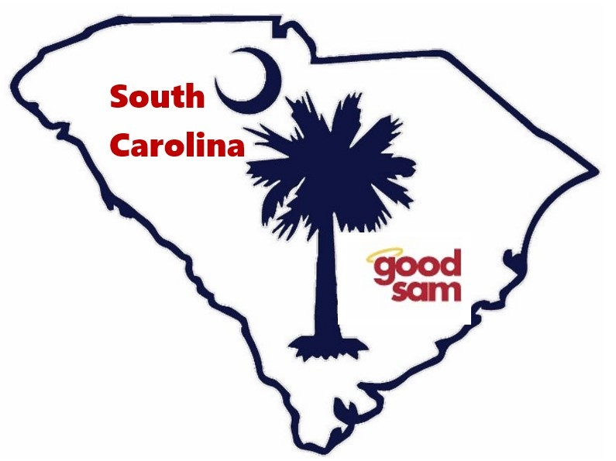
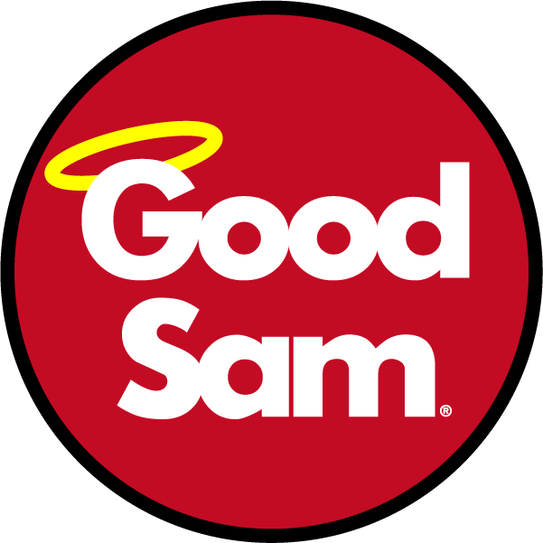
2022 Fall RV Rally
State Directors, Tim and Debbie Carroll
& the entire SC Good Sam Staff
Welcome you to our Rally
Theme – Up, Up and Away
Nov 3rd-6th, 2022

LOCATION: | Ocean Lakes Family Campground, 6001 S Kings Hwy, Myrtle Beach SC 29575
DATES: | Rally – Thursday, Nov 3rd through Sunday, Nov 6th - Early Bird starts Oct 30th
ACTIVITIES: | Entertainment (2 Nights), Continental Breakfasts (Fri/Sat), Catered Meal Friday night, Games, Samgo, Door Prizes, Hospitality, 50/50 drawing nightly, vendors, puzzles
CATERED MEAL: | Fried Pork Chops, Herb-Roasted Chicken, Mashed Potatoes with gravy, Green Beans, Banana Pudding.
THEME: | Up, Up and Away
REGISTRATION:
- NOTE CHANGE FROM PAST RALLIES: Due to policy changes at Ocean Lakes, you must call Ocean Lakes Family Campground (843-238-5636) directly to reserve/pay them and they will assign your site number rather than our Wagon Master. The earlier you call, the better your chances to camp together as a group. Cutoff for registration with Ocean Lakes is Oct 14th.
Tell them you are camping with SC Good Sam. Once assigned, you can then include your site # when you fill out the registration form below.
- Fill out the Registration form and follow instructions on page 2.
- Registration fee is for a single family—Single Family is defined as “Parent(s)/guardian & children under 18 years old.” All others are considered guests.

CANCELLATIONS: PLEASE NOTE PROCEDURE CHANGES
- Call Ocean Lakes (843-238-5636) and cancel your site reservations. Ocean Lakes has their own separate cancellation policy, so ask when you make your reservations.
- Call Mark Workman (843-834-2936) to cancel your rally registration
  - If received By Oct 21st – Honored/refunded, LESS a $5.00 cancellation fee.
  - If received after Oct 21st - NO REFUNDS
  - NO REFUND FOR NO SHOWS!!

2022 SOUTH CAROLINA FALL RV RALLY
Nov 3rd–6th 2022
Ocean Lakes Family Campground
6001 S Kings Hwy, Myrtle Beach, SC 29575
Theme – Up, Up and Away
SC State Directors: Tim & Debbie Carroll State Website: www.SCGoodSam.com
Name: Click or tap here to enter text. |  |  | EMAIL: Click or tap here to enter text.
Address: Click or tap here to enter text. |  |  |  | Phone: Click or tap here to enter text.
Good Sam #: Click or tap here to enter text. |  | Chapter Name: Click or tap here to enter text. |  |  | Site #: Click or tap here to enter text.
# Adults: | # Children (<18): |  | Your first SC Rally? YES ☐ NO ☐

REGISTRATION FEE

Registration Fee per family |  |  | $ 65 |  | $
Single Person |  |  | $ 45 |  | $
Additional people | Per Person |  | $ 45 X | # | $
Catered Meal (Friday night) | Per Person |  | $ 15 X | # | $
 |  | Grand Total |  |  | $ Click or tap here to enter text.
RALLY FEES: Make checks payable to: South Carolina Good Sam

Mail to: SC Rally
c/o Mark Workman
5909 Ryan’s Bluff
North Charleston SC 29418
Cell Phone 843-834-2936 EMAIL – awdw14@knology.net
We, the undersigned, understand and agree that South Carolina Good Sam (officers, staff and committees) has taken all reasonable and necessary precautions with regards to participants and visitors to the Rally. We therefore accept full responsibility for our unit, occupants and guests while attending this Rally and any other function related thereto.
__________________________________ Date: Click or tap to enter a date.
Signature

**REFUND POLICY: NO REFUNDS FOR NO SHOWS**

